EXPERIMENT-09

* **AIM: -** To design and implement a simple Library Management UI that allows users to search for books, add new books, and remove existing books, demonstrating core full-stack development concepts.
* **THEORY: -** Full Stack Development integrates both frontend (UI/UX) and backend (server, database).
* The frontend (React/HTML + CSS) enables interaction like search, add, and remove.
* The backend (Node.js + Express) handles data storage and retrieval.
* A database (MongoDB / in-memory for demo) stores book records (title, author, id).
* REST APIs (GET, POST, DELETE) facilitate communication between frontend and backend.
* Search functionality is implemented via string matching on book titles/authors.

# CODE: -

1. **BACKEND**→

// backend/index.js

const express = require("express"); const cors = require("cors");

const app = express(); app.use(cors()); app.use(express.json());

let books = [

{ id: 1, title: "Harry Potter", author: "J.K. Rowling" },

{ id: 2, title: "The Alchemist", author: "Paulo Coelho" },

];

// Get all books app.get("/books", (req, res) => { res.json(books);

});

// Add a new book app.post("/books", (req, res) => { const { title, author } = req.body;

const newBook = { id: books.length + 1, title, author }; books.push(newBook);

res.json(newBook);

});

// Delete a book app.delete("/books/:id", (req, res) => { const { id } = req.params;

books = books.filter((book) => book.id !== parseInt(id)); res.json({ message: "Book removed" });

});

app.listen(5000, () => console.log("Server running on port 5000"));

# FRONTEND→

// frontend/App.js

import React, { useState, useEffect } from "react";

function App() {

const [books, setBooks] = useState([]); const [search, setSearch] = useState(""); const [title, setTitle] = useState(""); const [author, setAuthor] = useState("");

useEffect(() => { fetch(["http://localhost:5000/books](http://localhost:5000/books)")

.then(res => res.json())

.then(data => setBooks(data));

}, []);

const addBook = () => { fetch(["http://localhost:5000/books](http://localhost:5000/books)", { method: "POST",

headers: { "Content-Type": "application/json" }, body: JSON.stringify({ title, author }),

})

.then(res => res.json())

.then(data => setBooks([...books, data]));

};

const removeBook = (id) => { fetch([`http://localhost:5000/books/$](http://localhost:5000/books/%24){id}`, { method:

"DELETE" })

.then(() => setBooks(books.filter(book => book.id !== id)));

};

return (

<div className="p-6 max-w-lg mx-auto">

<h1 className="text-2xl font-bold mb-4">µ–H‘ l_ µ_' Library Management</h1>

{/* Search */}

<input type="text"

placeholder="Search book..." className="border p-2 w-full mb-4" value={search}

onChange={(e) => setSearch(e.target.value)}

/>

{/* Add Book */}

<div className="flex gap-2 mb-4">

<input type="text" placeholder="Title" className="border p-2"

value={title} onChange={(e) => setTitle(e.target.value)} />

<input type="text" placeholder="Author" className="border p-2"

value={author} onChange={(e) => setAuthor(e.target.value)} />

<button onClick={addBook} className="bg-blue-500 text-white px-3 rounded">

Add

</button>

</div>

{/* Book List */}

<ul>

{books

.filter(b => b.title.toLowerCase().includes(search.toLowerCase()))

.map((book) => (

<li key={book.id} className="flex justify-between items-center border-b py-2">

<span>{book.title} — {book.author}</span>

<button onClick={() => removeBook(book.id)} className="bg-red-500 text-white px-2 rounded">

Remove

</button>

</li>

))}

</ul>

</div>

);

}

export default App;

# OUTPUT→

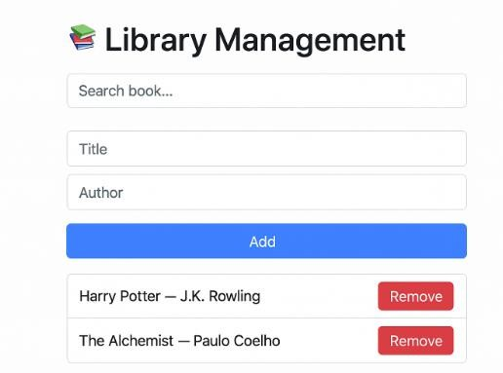

* **LEARNING OUTCOMES**→
* Understood integration of frontend and backend in a full-stack app.
* Learned how to implement CRUD operations (Create, Read, Delete) in REST APIs.
* Practiced state management in React with dynamic updates.
* Understood how to handle search filters in frontend UI.
* Gained experience in designing a realistic library management prototype.